**NXTFolio - Iteration 1**

Team Members

· Guang Hui Liew – Scrum Master

· Piyush Sharan – Scrum Master

· Quanqi Hu

· Vishnuvasan Raghuraman – Product Owner

Links

GitHub repo:<https://github.com/FashioNXT/NXTFolio/tree/fall2023>

Pivotal Tracker:<https://www.pivotaltracker.com/n/projects/2635646>

Slack:<https://app.slack.com/client/T05RUQT9FQB/C05REBYT4S3>

Deploy: [https://nxtfolio.herokuapp.com](https://nxtfolio.herokuapp.com/)

Client Meeting

**Customer Meeting:** Zoom, Friday, 29 Sept - 6 pm

9/22/2023 - Client meeting summary

We engaged in a comprehensive discussion with the client concerning our development priorities for the upcoming weeks. These priorities encompass the implementation of new features, including the integration of an AI Chatbot for user inquiries, the introduction of Collaborator-only comments to enhance comment quality, and the incorporation of a Reverse Image search feature to extract keywords and display relevant posts. During the meeting, we gained a deeper understanding of these features, which will significantly contribute to our project's progress. Additionally, we addressed critical issues related to legacy features and tests. Our Heroku deployment revealed data inconsistencies from the previous semester, prompting us to promptly notify the Spring '23 team via email. Furthermore, our legacy tests, utilizing Cucumber, were encountering challenges, with 76 out of 78 scenarios failing. In consultation with the client, we collectively decided to prioritize resolving these issues to establish a robust foundation for our upcoming development efforts.

User Stories Implementation

Chosen User Stories ->

**Feature: Job Posting, Mobile view (Incompletely Developed last semester)**

As a Developer,

So that I can complete legacy features,

I want to complete legacy features which are not available on the master branch

due to some issues and lacking areas which need to be fixed.

**Feature: Legacy Code Understanding and Automation Testing**

As a Developer,

So that I can test features,

I want to setup automation and test framework so that I am successfully able to

Test the cucumber tests, and specs and verify the code coverage.

We have picked the above 2 user stories to work on for this iteration.

**User Story 1:**

The job posting feature was merged with the master branch last semester but it is not actually working. The tests were failing and we were unable to create job listings manually.

Similarly, the Mobile View has a lot of missing functionality in key areas.

We contacted the previous development team regarding the missing areas within these two features, they verified that a few key aspects such as correct routing, missing UI, and multiple merge conflicts, etc. still need to be addressed in the codebase for the mobile view.

We have found the issues and moving forward we will be fixing these on priority depending on customer requirements.

For the Mobile view, we have added Cucumber tests and tested them manually. This is mainly due to the fact that Selenium web-driver + Cucumber is not working correctly. We have mailed the legacy team long back and followed up but haven’t gotten replies. We have added test cases for happy and sad paths but all these are testable only by making Pull requests. (or manually testable)

We found a workaround using GitHub Actions, which runs the cucumber and Rspec tests automatically when we make a pull request. (More details in the testing section)

**User Story 2:** ( **Changes to User Stories )**

We have added a new User story to correctly represent the work done regarding legacy testing and completed this user story successfully. (More details in the testing section)

Legacy User Stories (Rewritten & Refactored)

There are issues with both legacy features (job posting, and mobile view).

Since Job Posting was already merged with the master branch last semester, we will engage with the previous team for solutions. Currently, while posting for any job the website throws lots of errors. We will be discussing the priorities of features with the client in upcoming meet.

As for Mobile View, it will be a feature we continue to fix and develop this semester.

Some of the issues identified for Mobile View:

1. Routing Errors



1. Gallery (Picture overlaps with texts below)
2. The user interface doesn’t work well and requires significant efforts to fix.
3. The navbar is non-responsive most of the time, need to fix it.
4. The login page forms overlaps with the navbar.

and many more.

Test Cases and Coverage (SimpleCov & Cucumber + Rspec) :

We started by running the legacy Cucumber tests on a local deployment. After addressing a number of minor issues, the Cucumber tests were still failing across nearly all scenarios, yielding a coverage of only 3.37%. These results were inconsistent with the outcomes reported by the previous team. It was noteworthy that when we ran the tests on both PC and Mac, the errors causing the failures differed. On the Mac, a timeout error was encountered:



On the PC, a distinct error was observed:

**

Ultimately, we utilized the Github Action devised by the prior team, achieving a **coverage of 27.32%**, aligning with the previous team's reported results. To provide a precise breakdown, 47 out of 77 scenarios within the test suite passed.

We have been attempting to fix the issue on local testing since the beginning of iteration 1, but could not locate the bug. We tried to contact the previous team, but couldn’t get in touch with them until Sep. 29. We had a meeting on Sep. 29 and had a discussion. This problem seems to be a long-standing issue, primarily rooted in the webdriver connection, which is causing the local test failures. We plan to continue working on this.

Design Diagram (See attached file in i1.tar) :

In this iteration, we focused on working on the legacy features (job posting and mobile view) and setting up the automation tests using cucumber and code coverage.

We have re-designed the legacy design diagram and added our new implementation onto the diagram. The full diagram is attached in the submission folder.

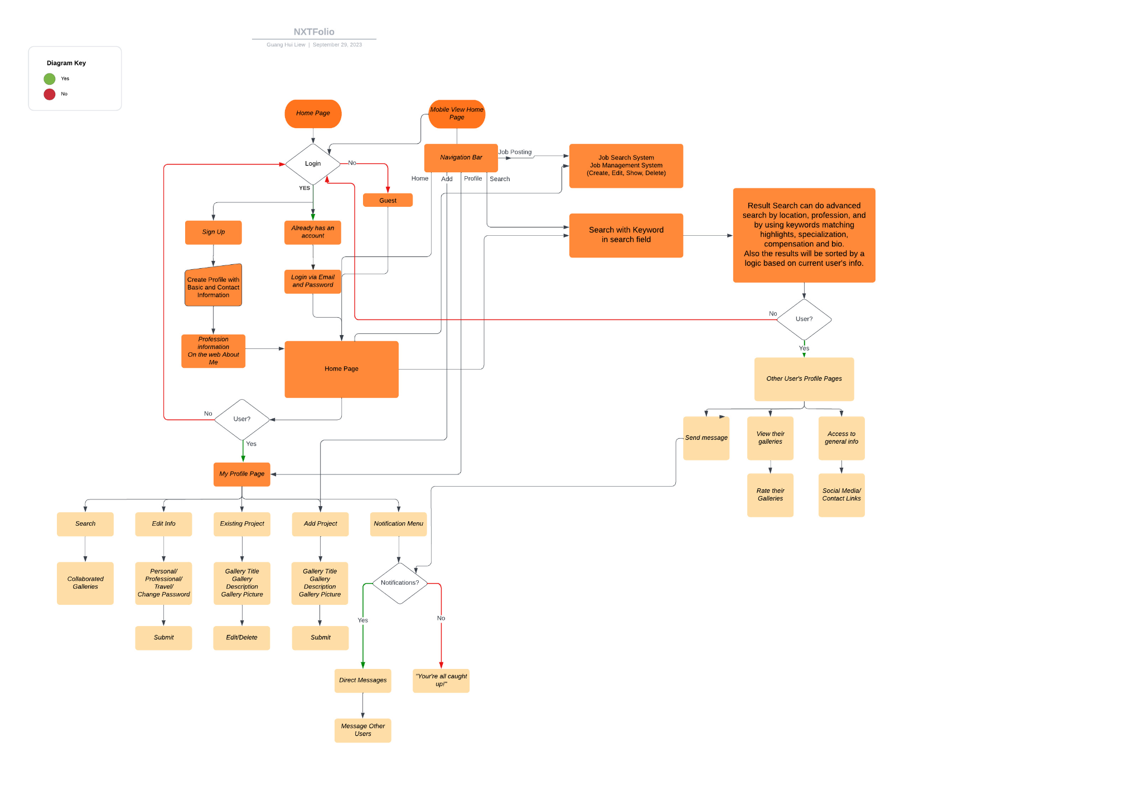

Deployment and Customer Feedback

No new features were introduced on Heroku following the initial deployment. This was primarily because of lingering issues in the legacy code, such as failed tests and non-functional mobile views and job postings. Consequently, the customer requested that we prioritize addressing these issues before embarking on the next phase of feature development. Additionally, the customer expressed the desire to have all the previously associated database-related data restored on Heroku, including credentials and post content.

Production & System Customer Transfer

The repository is uploaded to the client’s GitHub and deployed on Heroku with the client’s credentials.

Burndown Chart

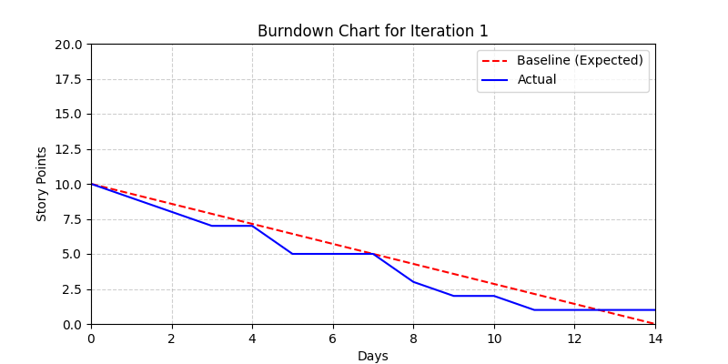

Member’s Effort

Total Points = 12

|  | Guang Hui Liew | Piyush Sharan | Quanqi Hu | Vishnuvasan Raghuraman |
| --- | --- | --- | --- | --- |
| Points | 3 | 3 | 3 | 3 |
| Effort | 100% | 100% | 100% | 100% |

Pivotal Tracker: <https://www.pivotaltracker.com/n/projects/2635646>